**Aim: To write a c-program for implement the Cyclic Redundancy Check(CRC).**

Theory :

The Cyclic Redundancy Checks (CRCs) is the most powerful method for Error-Detection and Correction.

Error: A condition when the receiver’s information does not matches with the sender’s information. During transmission, digital signals suffer from noise that can introduce errors in the binary bits travelling from sender to receiver. That means a 0 bit may change to 1 or a 1 bit may change to 0.

CRC is based on binary

* In CRC, a sequence of redundant bits, called cyclic redundancy check bits, are appended to the end of data unit so that the resulting data unit becomes exactly divisible by a second, predetermined binary
* At the destination, the incoming data unit is divided by the same number. If at this step there is no remainder, the data unit is assumed to be correct.

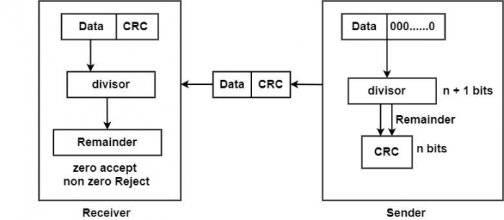

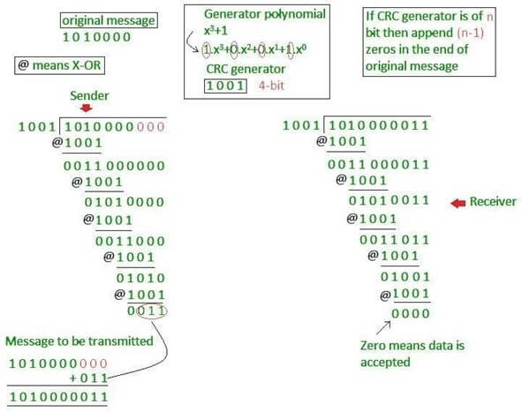

**Program:**

#include <stdio.h>

#include <stdlib.h>

void xor_division(int a[], int g[], int m, int n, int r[], int div[]) {

int i, j, k = 0;

for (i = 0; i <= n; i++)

r[i] = a[i];

for (i = n; i <= m + n; i++) {

if (i > n) {

for (j = 0; j < n; j++)

r[j] = r[j + 1];

r[j] = a[i];

}

if (r[0])

div[k++] = 1;

else {

div[k++] = 0;

continue;

}

for (j = 0; j <= n; j++)

r[j] = r[j] ^ g[j];

}

}

int main() {

int i, j, k = 0;

int flag = 1;

int a[50], g[20], r[20], div[50];

int n, m;

system("clear");

printf("Enter degree of generator: ");

scanf("%d", &n);

printf("Enter the generator (in binary):\n");

for (i = 0; i <= n; i++)

scanf("%d", &g[i]);

printf("Enter the degree of the frame: ");

scanf("%d", &m);

printf("Enter the frame (in binary):\n");

for (i = 0; i <= m; i++)

scanf("%d", &a[i]);

if (m < n || g[0] == 0) {

printf("Not a proper generator.\n");

exit(0);

}

for (i = m + 1; i <= m + n; i++)

a[i] = 0;

xor_division(a, g, m, n, r, div);

printf("\nQuotient is: ");

for (j = 0; j < m + 1; j++)

printf("%d", div[j]);

printf("\nRemainder is: ");

for (i = 1; i <= n; i++)

printf("%d", r[i]);

printf("\nTransmitted frame is: ");

for (i = 0; i <= m; i++)

printf("%d", a[i]);

for (i = 1; i <= n; i++) {

a[m + i] = r[i]; // Append CRC bits

printf("%d", r[i]);

}

printf("\n");

// Receive frame

printf("\nEnter the degree of received frame: ");

scanf("%d", &m);

printf("Enter the received frame:\n");

for (i = 0; i <= m; i++)

scanf("%d", &a[i]);

k = 0;

xor_division(a, g, m - n, n, r, div); // m - n because frame includes CRC

printf("\nQuotient is: ");

for (j = 0; j <= m - n; j++)

printf("%d", div[j]);

printf("\nRemainder is: ");

for (i = 1; i <= n; i++)

printf("%d", r[i]);

flag = 1;

for (i = 1; i <= n; i++) {

if (r[i]) flag = 0;

}

if (flag)

printf("\nNo Error Detected.\n");

else

printf("\nError Detected in Received Frame.\n");

return 0;

}

##### Output:

Enter the degree of the generator: 3

Enter the generator: 1 0 0 1

Enter the degree of the frame: 7

Enter the frame :

1

1

1

1

1

1

1

1

Quotient is : 11100011

Remainder is: 011

Transmitted frame is: 11111111011

Enter the degree of the frame:10

Enter the frame:

1

1

1

1

1

1

1

1

0

1

1

Quotient is: 11100011

Remainder is:000

No Error